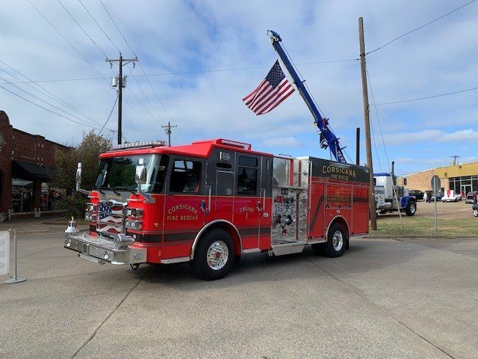
CORSICANA FIRE RESCUE
Annual Report
corsicana fire rescue | 2975 Drane Rd

CY 2022
CY 2022 End of Year Review
Total Incidents
- Total Incidents for Calendar Year 2022 was 3961 (Including exposure fires) and 3956 without exposure. This was a decrease from 8,240 seen in FY 2021. This decline is attributed directly to the contracting of ambulance services which began in December 2021.

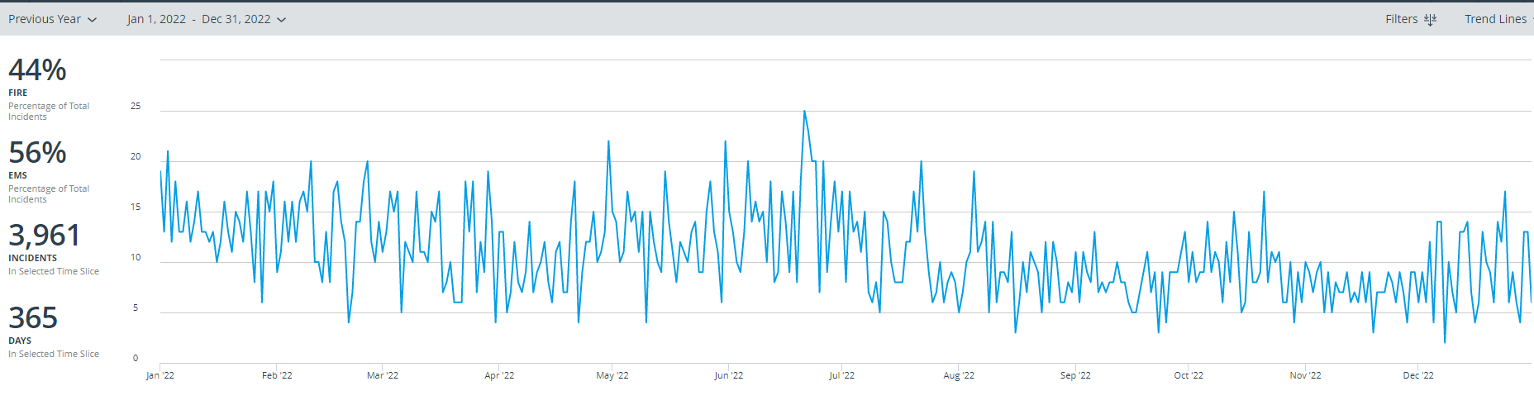
Incident Locations
- For all incidents, 3735 or 95% occurred in The City of Corsicana and 214 or 5% occurred in Navarro County. 7 Incidents were classified as out of district and account for less than 1%.

All Incident Types
- In CY 2022, all incident types for Fire Departments as follows. Corsicana Fire Rescue responded to 3,956 Calls for Service. 56% of incidents were EMS incidents equating to 2,220. The remaining
44% of incidents were as follows: 216 Fires, 172 Hazardous Conditions, 458 Service Calls, 674 Cancelled or Good Intent, 212 False Alarms, 1 Severe Weather or Natural Disaster, and 3 Special Incidents.

City Incident Types
- In CY 2022, all incident types in the City of Corsicana for Fire and EMS were as follows. Corsicana Fire Rescue responded to 3,735 Calls for Service. 57% of incidents were EMS incidents equating to 2,120. The remaining 43% of incidents were as follows: 145 Fires, 169 Hazardous Conditions, 455 Service Calls, 631 Cancelled or Good Intent, 211 False Alarms, 1 Severe Weather or Natural Disaster, and 3 Special Incidents.

County Incident Types

- In CY 2022, all incident types in Navarro County for CFR were as follows. Corsicana Fire Rescue responded to 214 Calls for Service. 46% of incidents were EMS incidents equating to 98. The remaining 54% of incidents were as follows: 68 Fires, 3 Hazardous Conditions, 2 Service Calls, 42 Cancelled or Good Intent, and 1 False Alarms.

Fire Apparatus Responses
- The following reports show the total responses made by fire engines in 2022. Corsicana Fire Rescue Engines responded 4,310 times total. Engines responded 4,076 times in the City and 227 times into the county, 7 incidents were classified as Out of District. (Often times multiple engines will respond to the same Incident therefore responses will exceed incidents)

Engine Response Times in City of Corsicana
- The Average response time in the city for all engines and Unit 803(Shift Commander) was 6.2 minutes.

Ambulance Responses
- In CY 2022 Corsicana Fire Rescue made 45 ambulance responses with Medic 7. Of these, 30 resulted in transport.
Disposition | Total
Cancelled (No Patient Contact) | 1
Cancelled (Prior to Arrival at Scene) | 3
Cancelled on Scene/No Patient Found | 1
Patient Dead on Scene - No Resuscitation Attempted (Without Transport) | 2
Patient Refused Evaluation/Care (Without Transport) | 2
Patient Treated, Released (AMA) | 4
Patient Treated, Transferred Care to Another EMS Professional/Unit | 2
Transported No Lights/Siren | 30
Total | 45

Allegiance Mobile Health Activity
During CY 2022, AMH responded to 6,061 emergency incidents. Additionally, they transferred 1,024 patients. Their total number of incidents was 7,085. Of these 5,172 or 73% (including transfers) originated in the City and 1,913 or 27% originated in the County.

Fire Prevention-Community Risk Reduction
- Total inspections performed for CY 2022 was 370. Of these inspections, 435 violations were found and 328 violations have been corrected. There were 178 reinspections performed

- In addition, 223 Fire Safety Surveys were performed.
- 657 Hydrants Flowed
- 122 Talks and Demonstrations for 2,653 Contacts
- 14 Fire Investigations occurred. 8 were determined as accidental and 6 were undetermined.
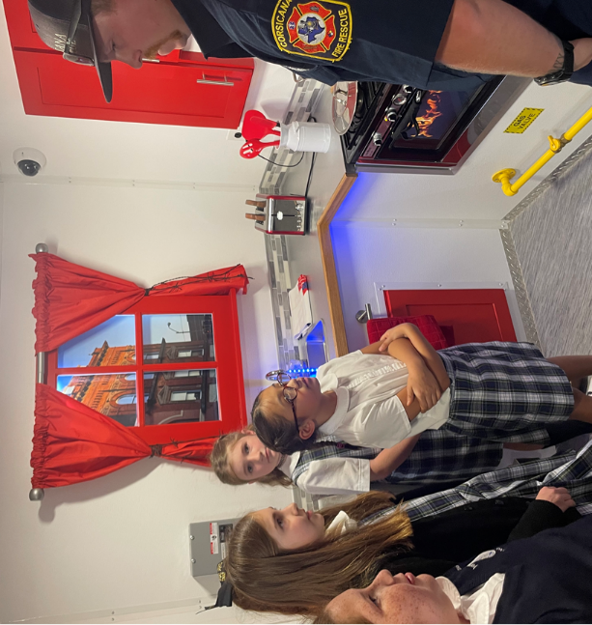

Training
- (6) TCFP certifications were upgraded and (21) new certifications added
- (15) recruit firefighters logged over 1500 hours of probationary fire training
- (30) members logged 1060 hours of training at off-site locations
- (34) members logged 1040 hours of training brought to our department at no cost from state sponsored training groups
- (2) members obtained their paramedic certification
- (42) members from operations logged over 6529 total training hours at the company level
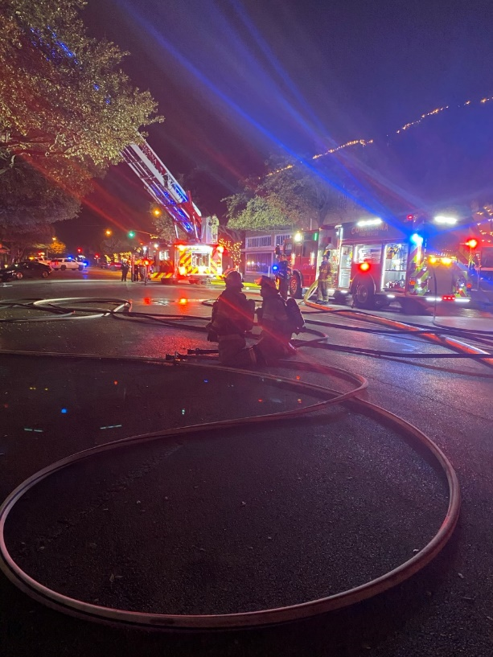
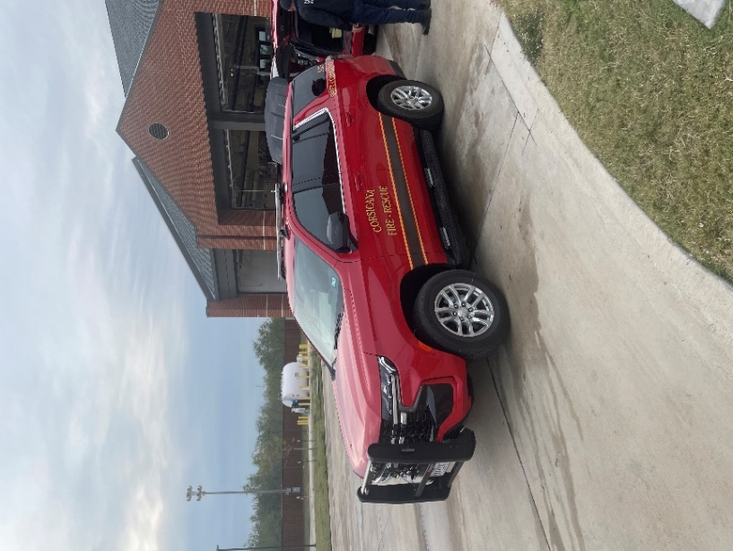

Departmental and Community Upgrades
- Through the Budget
  - Replaced the Shift Commander vehicle with a new 2022 Chevy Tahoe Command Vehicle
  - Replaced Fire Service Hose
  - Acquired 6 new Life Pak 15 Cardiac Monitors
  - Added three new Lieutenant Positions that allows for one Lieutenant at each Fire Station/Company
- Through other funding
  - Replaced the 2000 model Fire Safety House with a new state of the art Fire Safety Simulator Trailer through Community Foundation
  - Replaced 21 Mobile radios, 3 repeaters, 10 mobile radios and 11 base station radios through the FEMA Assistance for Firefighter Grant program
  - Added 10 AEDs to include all City of Corsicana parks through funding by Corsicana Health Support Foundation

