CORSICANA FIRE RESCUE 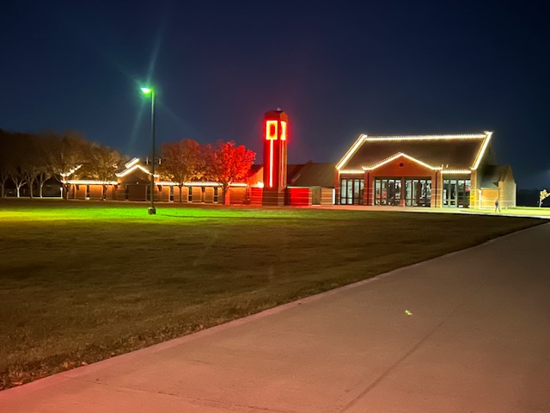
Annual Report
corsicana fire rescue | 2975 Drane Rd

2024
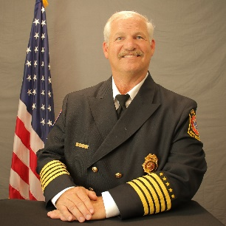
FROM THE DESK OF FIRE CHIEF MIKE RYAN

Mission Statement
Our Mission is to maintain a continuous state of readiness to protect those we serve and to provide the highest quality of services when called upon.

Vision
Our Vision is to be a well-respected and progressive fire department. Our department will always strive to gain the mutual trust, respect, and support of our community through continuous improvement, guided by our core values of integrity, courage, dedication, and compassion.

Values
As members of the Corsicana Fire Department, we are committed to the following values in our interactions with our co-workers and citizens.
- Professionalism - In application, appearance, and attitude
- Integrity - Demonstrate honesty and fairness
- Compassion - Demonstrate kindness and empathy
- Accountability - Professionally, personally, and fiscally responsible for our actions
- Respect - For each other, our department, and everyone we come in contact with
- Diversity - Be open minded and responsive to the uniqueness of our community
- Commitment - In all department endeavors
- Teamwork - Encourage unity and a cooperative attitude
2024 was a successful year for Corsicana Fire Department. We are committed to serving our community while upholding our organizational values. CFD works tirelessly to meet our stakeholders’ expectations of service delivery whilst presenting a professional image to the public. Please enjoy this report as it represents our commitment to our community and the members of Corsicana Fire Department.

CY 2024 End of Year Review
BY THE NUMBERS
Total Incidents
- Total Incidents for Calendar Year 2024 was 3,404 (Including exposure fires) and 3,401 without exposure. This was an increase from 3,159 seen in CY 2023.

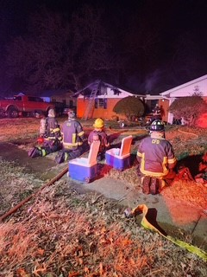
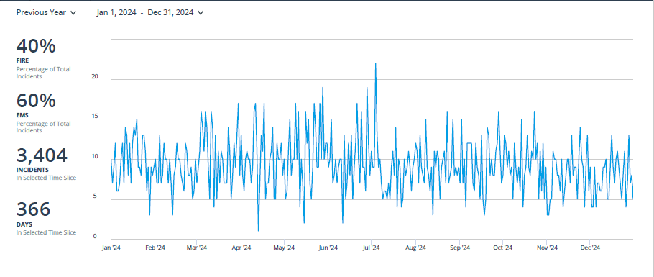

Incident Locations
- For all incidents, 3,188 or 94% occurred in The City of Corsicana and 213 or 6% occurred in Navarro County

All Incident Types
- In CY 2024, all incident types for Fire Departments as follows. Corsicana Fire Rescue responded to 3,401 Calls for Service. 61% of incidents were EMS incidents equating to 2,056. The remaining
39% of incidents were as follows: 159 Fires, 2 Overpressure/Ruptures, 214 Hazardous Conditions, 398 Service Calls, 351 Cancelled or Good Intent, 218 False Alarms, and 3 Special Incidents.

City Incident Types
- In CY 2024, all incident types in the City of Corsicana for Fire and EMS were as follows. Corsicana Fire Rescue responded to 3,188 Calls for Service. 61% of incidents were EMS incidents equating to 1,952. The remaining 39% of incidents were as follows: 105 Fires, 1 Overpressure/Rupture, 201 Hazardous Conditions, 392 Service Calls, 311 Cancelled or Good Intent, 214 False Alarms, and 3 Special Incidents.

County Incident Types

- In CY 2024, all incident types in Navarro County for CFR were as follows. Corsicana Fire Rescue responded to 213 Calls for Service. 49% of incidents were EMS incidents equating to 104. The remaining 51% of incidents were as follows: 54 Fires, 1 Overpressure Rupture, 4 Hazardous Conditions, 6 Service Calls, 40 Cancelled or Good Intent, and 4 False Alarms.

Fire Apparatus Responses
- The following reports show the total responses made by fire engines in 2024. Corsicana Fire Rescue Engines responded 3,691 times total. Engines responded 3,475 times in the City and 216 times into the county. (Often times multiple engines will respond to the same Incident therefore responses will exceed incidents)

Engine Response Times in City of Corsicana
- The Average response time in the City for all engines and Unit 803 (Shift Commander) was 6.05 minutes.

Ambulance Responses
MEDIC 7 by Disposition | Total
Patient Refused Evaluation/Care (Without Transport) | 7
Transported Lights/Siren | 10
Transported No Lights/Siren | 28
Transported No Lights/Siren, Upgraded | 1
Total | 46
- In CY 2024 Corsicana Fire Rescue made 46 ambulance responses with Medic 7. Of these, 39 resulted in transport.

Allegiance Mobile Health Activity
During CY 2024, AMH responded to 6,616 emergency incidents. Additionally, they had 1,252 interfacility transfer patients. Their total number of incidents was 7,868. Of these 5,510 or 70% (including transfers) originated in the City and 2,358 or 30% originated in the County.

Fire Prevention-Community Risk Reduction
Total inspections performed for CY 2024 was 265. Of these inspections, 248 violations were found, and 260 violations have been corrected (Some Violations Corrected that were identified in 2023). There were 98 reinspections performed

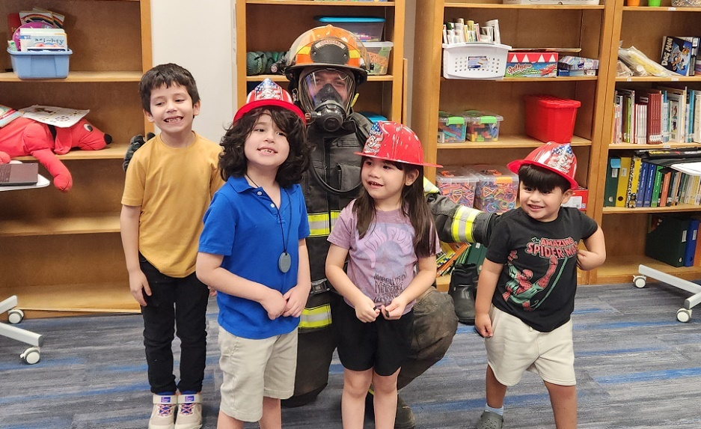
- In addition, 309 Fire Safety Surveys were performed.
- 109 Hydrants Flowed
- 55 Talks and Demonstrations for 5,227 Contacts!
- 18 Fire Investigations occurred. 7 were determined as accidental, 5 Incendiary, 4 were undetermined, and 2 remain under investigation.
Training
The Training Division had another productive year in 2024. Over 3,960 training hours were logged in our Record Management System encompassing company level and certification training. 59 new Texas Commission on Fire Protection (TCFP) certifications were obtained as well as 16 existing certifications being upgraded to a higher level.
Conferences/Offsite Training /Hosted Classes Attended:
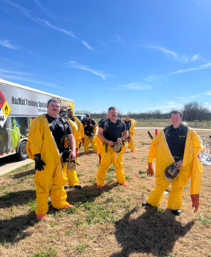
- Texas Fire Chief’s Association (TFCA) 2nd In Command
- TFCA Administrative Professional Assistant Workshop
- TDEM H501 HazMat Technician Certification Class (Corsicana)
- TFCA Annual Conference
- TEEX Officer 3 @ DeSoto Fire Training Center
- TFCA Battalion Chief’s Academy
- TEEX Officer 4 @ Desoto Fire Training Center
- TDEM Emergency Management Conference
- New Fire Investigator Course (Grand Prairie PD)
- TEEX Municipal Fire School
- Rescue Boat Operator Triad Rescue
- Traffic Incident Safety Management (NTCOG Arlington)
- Basic Swiftwater Technician Triad Rescue
- TCFP Fire Officer 1 Certification Course (Athens FD)
- Fire Death Forensic Class (San Marcos)
- TLFFRA Conference
- Senior Command Staff served as instructors for the 2024 Area Fire School for the Navarro County Volunteer Firefighters Association.
The following spreadsheet shows the TCFP certifications currently held by the members of the fire department. Fields in red were preexisting certifications and fields in yellow depict the certifications obtained in the calendar year of 2024.

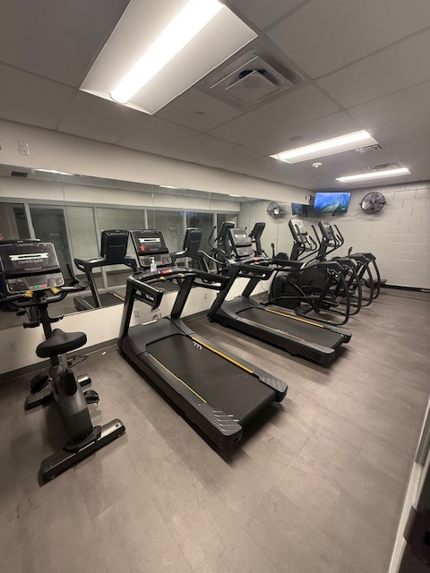
Departmental and Community Upgrades
- Through the Budget
  - Implemented 12 Driver/Engineer Positions
  - Acquired 2 sets of High-Pressure Rescue Airbags
- Through other funding
  - Through a FEMA Assistance to Firefighters Grant (AFG)-Acquired new cardiovascular equipment for the 4 fire stations to include 5 treadmills, 4 ellipticals, 1 indoor bicycle, and 2 rowers.
  - Through the same AFG, implemented NFPA 1582 Health and Wellness assessments for personnel. Resulted in identifying a member with a significant finding.
  - Through the Corsicana Health Support Foundation acquired an adult simulation manikin to practice advanced life support skills.

SWOT Analysis for FY 2026 Planning
- Strengths
  - Our greatest strength at Corsicana Fire Department is the knowledge, skills, and abilities of our personnel. Members are professional and lifelong learners that continually hone their craft. They are well respected throughout this community and serve as ambassadors for the City of Corsicana Fire Department. We strive for excellence in every opportunity.
- Weaknesses
  - Currently each shift has 14 members and a daily minimum of 13 members. One additional member is needed per shift to cover all discretionary leave and off-site training.
- Opportunities
  - Consider utilizing a Fire Apparatus Lease program to ensure that apparatus are replaced in a timely and cost-efficient manner. Could potentially save on preventative maintenance costs.
- Threats
  - Rising Cost of Apparatus and Apparatus Repairs
AWARDS & PROMOTION
Promotions
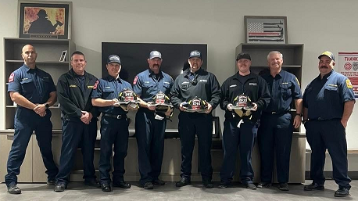
- Driver Engineer
  - James Glasgow
  - James Reed
  - Ryan Farish
  - Corey McDougald
  - Taylor Pollock
  - Matt Bell
  - Alexis Manriquez
  - Jacob Sanchez
  - James Page
  - Richard Hays
  - Michael Jurik
  - Kolby Parker
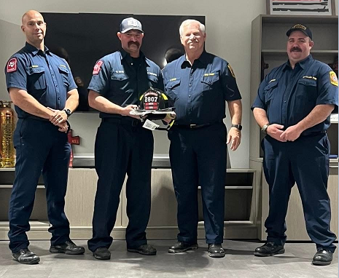
- Captain
  - Richard Hays
- Battalion Chief/Fire Marshal
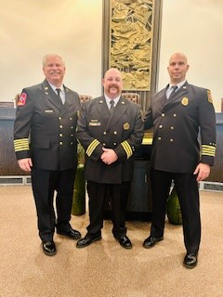
  - Brian Mundie
